SCHOOL OF COMPUTER SCIENCE AND ARTIFICIAL INTELLIGENCE |  |  |  |  | DEPARTMENT OF COMPUTER SCIENCE ENGINEERING
ProgramName:B. Tech |  |  |  | Assignment Type: Lab |  |  | AcademicYear:2025-2026
CourseCoordinatorName |  |  |  | Venkataramana Veeramsetty
Instructor(s)Name |  |  |  | Dr. V. Venkataramana (Co-ordinator)  Dr. T. Sampath Kumar  Dr. Pramoda Patro  Dr. Brij Kishor Tiwari  Dr.J.Ravichander  Dr. Mohammand Ali Shaik  Dr. Anirodh Kumar  Mr. S.Naresh Kumar  Dr. RAJESH VELPULA  Mr. Kundhan Kumar  Ms. Ch.Rajitha  Mr. M Prakash  Mr. B.Raju  Intern 1 (Dharma teja)  Intern 2 (Sai Prasad)  Intern 3 (Sowmya)  NS_2 ( Mounika)
CourseCode |  |  | 24CS002PC215 | CourseTitle |  | AI Assisted Coding
Year/Sem |  |  | II/I | Regulation |  | R24
Date and Day  of Assignment |  |  | Week1 - Wednesday | Time(s)
Duration |  |  | 2 Hours | Applicableto  Batches |  | 24CSBTB01 To 24CSBTB39
AssignmentNumber:2.3(Present assignment number)/24(Total number of assignments)
 | Q.No. | Question |  |  |  |  |  | ExpectedTime  to complete
 | 1 | Lab 2: Exploring Additional AI Coding Tools – Gemini (Colab) and Cursor AI  Lab Objectives:  - To explore and evaluate the functionality of Google Gemini for AI-assisted coding within Google Colab.  - To understand and use Cursor AI for code generation, explanation, and refactoring.  - To compare outputs and usability between Gemini, GitHub Copilot, and Cursor AI.  - To perform code optimization and documentation using AI tools.  Lab Outcomes (LOs):  After completing this lab, students will be able to:  - Generate Python code using Google Gemini in Google Colab.  - Analyze the effectiveness of code explanations and suggestions by Gemini.  - Set up and use Cursor AI for AI-powered coding assistance.  - Evaluate and refactor code using Cursor AI features.  - Compare AI tool behavior and code quality across different platforms.  Task Description#1  - Use Google Gemini in Colab to write a function that reads a CSV file and calculates mean, min, max.  Expected Output#1  - Functional code with output and screenshot  Task Description#2  - Compare Gemini and Copilot outputs for a palindrome check function.  Expected Output#2  - Side-by-side comparison and observations  Task Description#3  - Ask Gemini to explain a Python function (to calculate area of various shapes) line by line..  Expected Output#3  - Detailed explanation with code snippet  Task Description#4  - Install and configure Cursor AI. Use it to generate a Python function (e.g., sum of squares).  Expected Output#4  - Screenshots of working environments with few prompts to generate python code  Task Description#5  - Student need to write code to calculate sum of add number and even numbers in the list  Expected Output#5  - Refactored code written by student with improved logic  Note: Report should be submitted a word document for all tasks in a single document with prompts, comments & code explanation, and output and if required, screenshots  Evaluation Criteria:  Criteria Max Marks  Successful Use of Gemini in Colab (Task#1 & #2) 1.0  Code Explanation Accuracy (Gemini) (Task#3) 0.5  Cursor AI Setup and Usage (Task#4) 0.5  Refactoring and Improvement Analysis (Task#5) 0.5  Total 2.5 Marks |  |  |  |  |  | Week1 - Wednesday

LAB_ASSIGNMENT_2.3
TASK DESCRIPTION#1
- Use Google Gemini in colab to write a function that reads a CSV file and calculates mean, min, max.

PROMPT: Generate a code that allows to use Google Gemini in colab to write a function that reads a CSV file and calculates mean, min, max.

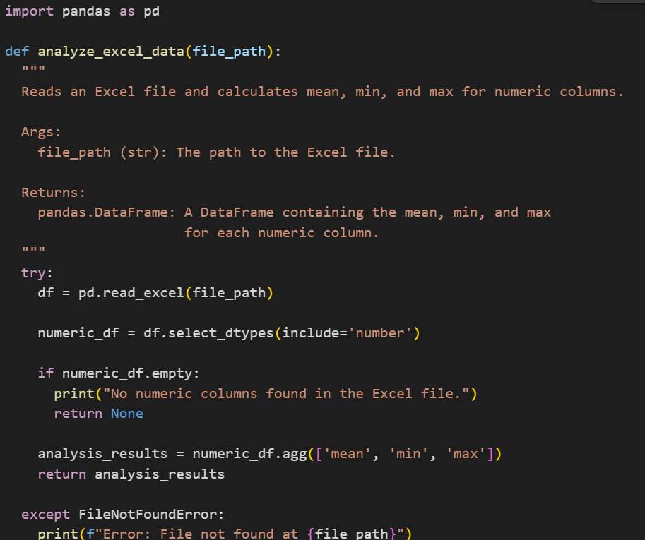
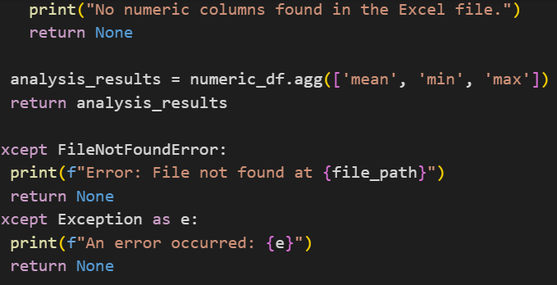
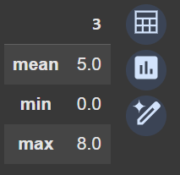

TASK DESCRIPTION#2
- Compare Gemini and Copilot outputs for a palindrome check function.

PROMPT:
Write a python function to check whether a given string is palindrome or not.Then, explain
the code briefly.

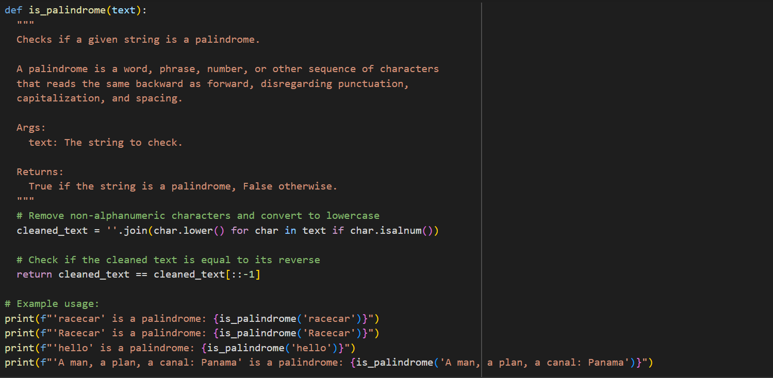

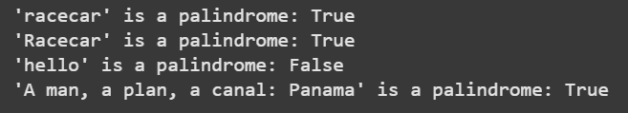

TASK DESCRIPTION#3
- Ask Gemini to explain a Python function (to calculate area of various shapes) line by line..

PROMPT:
Explain the following python function, which calculates the area of various geometric shapes, line by line which detailed comments.
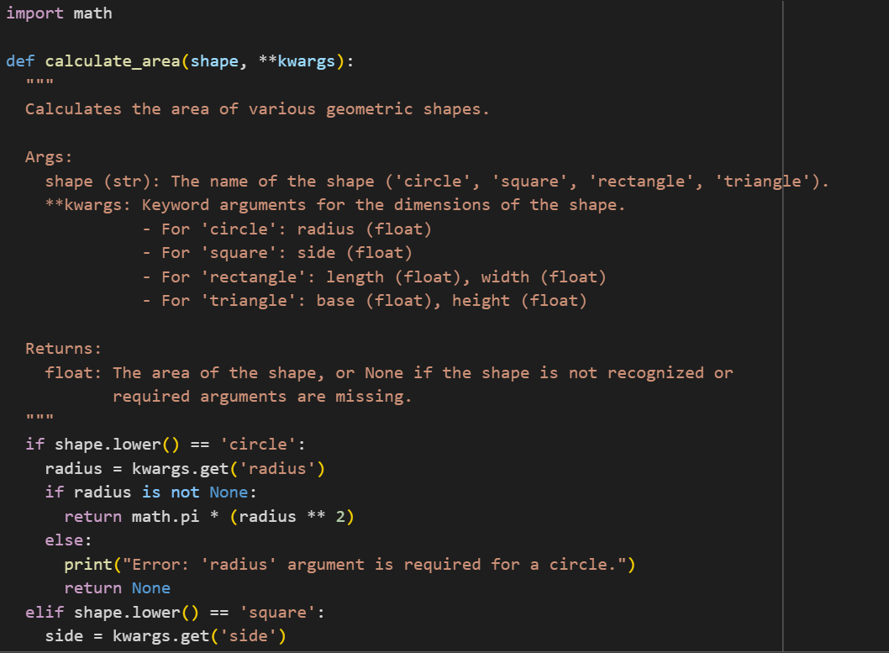
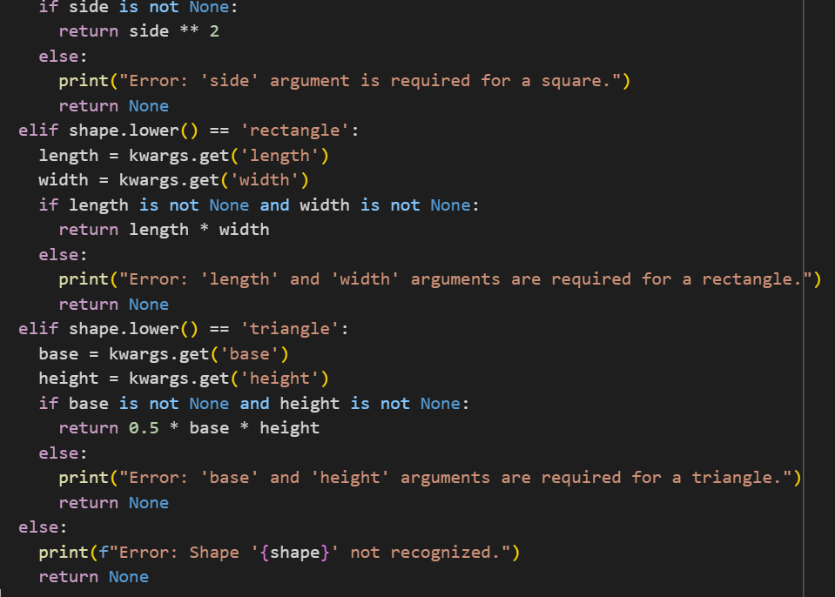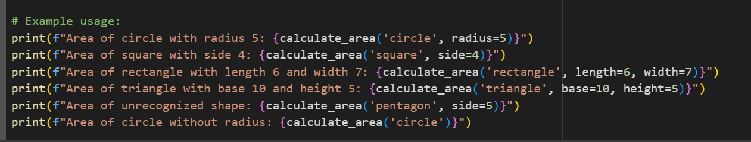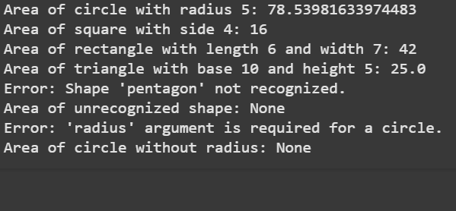

TASK DESCRIPTION#4
- Install and configure Cursor AI. Use it to generate a Python function (e.g., sum of squares).

PROMPT:
Write a python function that calculates the sum of squares of numbers 1 to n. The function should take n as input and return the result.

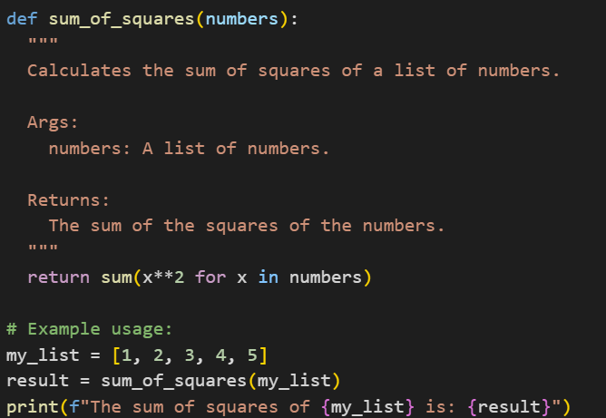
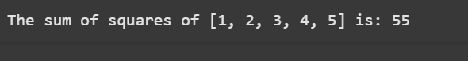

TASK DESCRIPTION#5
- Student need to write code to calculate sum of add number and even numbers in the list

PROMPT:
Generate a oython program that takes a list of numbers and calculates the sum of all odd numbers and the sum of even numbers in list seperately.

